**MARKET BASKET ANALYSIS**

M.Tech CSE

Y.Venkatesh-(17MCS0004)

M.Sai Praneeth-(17MCS0030)

S.Praveen Kumar-(17MCS0064)



**Table of contents**

1. Introduction
2. Problem statement
3. Objective
4. K-Apriori algorithm
5. References

**Problem statement**

* A retail outlet wants to understand the purchases behavior of a buyer. This information will enable the retailer to understand the buyers needs.
* The analysis might tell a retailer that customers often purchase items together ,so putting the items on promotion at the same time would create a significant increase in profit while a promotion involving just one of the items would likely drive sales of the other.

**Introduction**

* Market Basket Analysis (Association Analysis) is a mathematical modeling technique based upon the theory that if you buy a certain group of items, you are likely to buy another group of items.
* It is used to analyze the customer purchasing behavior and helps in increasing the sales and maintain inventory by focusing on the point of sale transaction data.
* Massive amounts of data continuously being collected and stored as transactions.
* Given a dataset, the Apriori Algorithm trains and identifies product baskets and product association rules.
* Market basket analysis is one of the data mining methods focusing on discovering purchasing patterns by extracting associations or co-occurrences from a store’s transactional data.
* Market basket analysis determines the products which are bought together and to reorganize the supermarket layout, and also to design promotional campaigns such that products’ purchase can be improved.
* Hence, the Market consumer behaviors need to be analyzed, which can be done through different data mining techniques.
* Association rule mining finds interesting association or correlation relationships among a large set of data items.

**Objective**

* To find frequently purchased item sets from large transactional database.

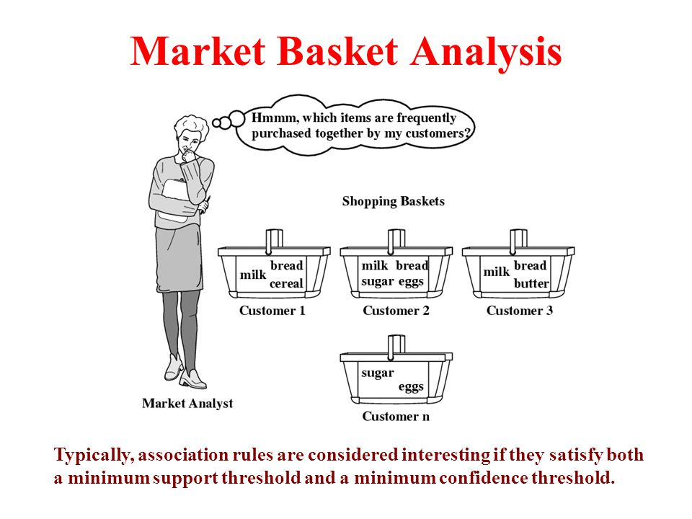

**K-Apriori algorithm**

Step: 1 this step simply scans allof the transactions in order to count the number of occurrences of each item, named it as C1.

Step: 2 Apply minimum support count, and items set that satisfies the condition named as L1. (Min support count =2).

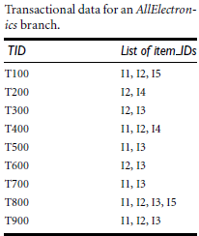

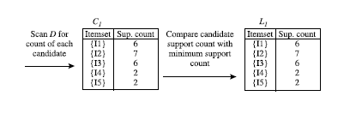

Step: 3 To discover the set of frequent 2-itemsets, L2, the algorithm uses the join L1XL1 to generate a candidate set of 2-itemsets, and count the occurrences of each set.

Step: 4 Apply min support count on C2*,* result will be 2-frequent item set L2.

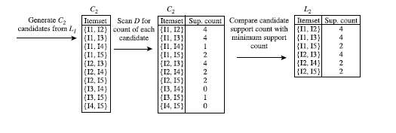

Step: 5 To generate 2-frequent item set, generate 3-item using L2XL2 and apply min support count which will be 3-frequent item set.

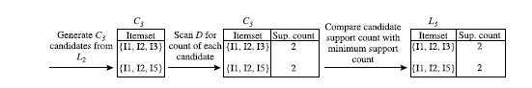

Step: 6 Continue until you get empty sets.

**References**

1. Loraine Charlet Annie M.C. and Ashok Kumar D, "Frequent Item set mining for Market Basket Data using K-Apriori algorithm" , International Journal of Computational Intelligence and Informatics, Volume 1, No. 1, 2011, pp.14-18.
2. Jiwawi Han and Micheline Kamber, Concepts and Techniques of Data Mining, 2nd ed., Jim Gray, Ed.: Morgon Kaufmann,Elsevier, 2012.
3. Berry, M.J.A., Linoff, G.S.: Data Mining Techniques: for Marketing, Sales and Customer Relationship Management (second edition), Hungry Minds Inc., 2004.
4. Chen, Y.-L., Tang, K., Shen, R.-J., Hu, Y.-H.: Market basket analysis in a multiple store environment, Decision Support Systems, 2004.